Lab 16: Using Kernel Debugging Commands with WinDbg
Course Name: Malware Analysis and Reverse Engineering (IAM302)
Student Name: Nguyễn Trần Vinh – SE160258
Instructor Name: Mai Hoàng Đỉnh
Lab Due Date: 15/3/2023

Purpose
Practice using simple WinDbg commands.

What You Need
A Windows 10 machine with Livekd working, as prepared in the previous project. This project should work on Win 7 or any later version, but I only tested it on Windows 10

Starting Configuration
You should have Livekd running, which launched WinDbg, as you did at the end of the previous project

Listing Modules with lm
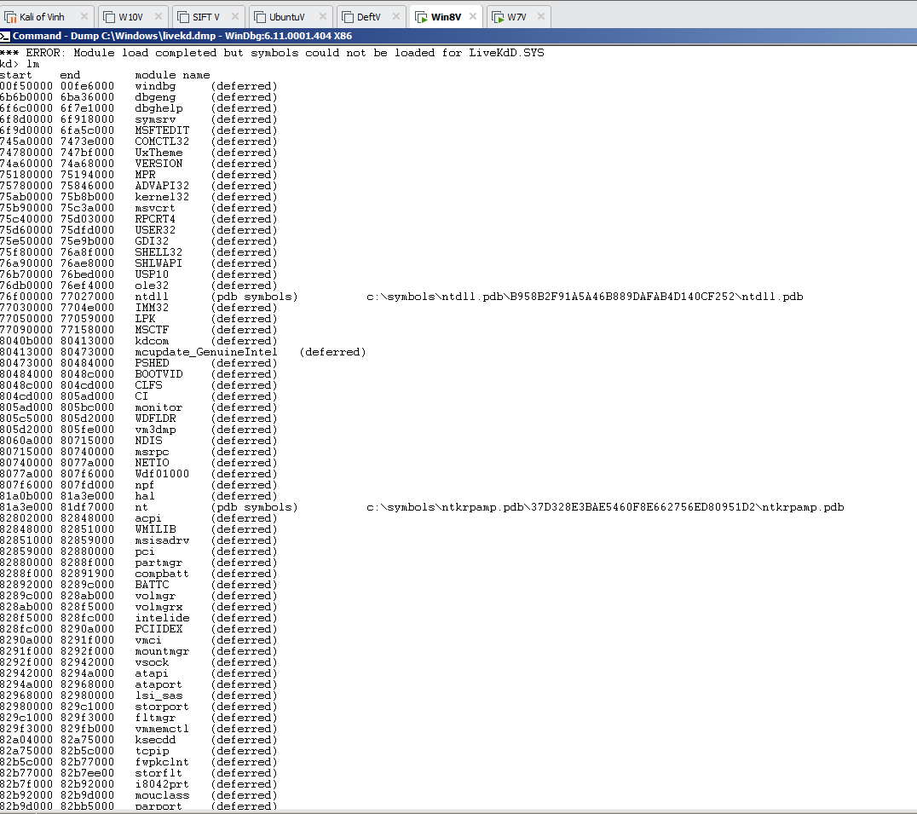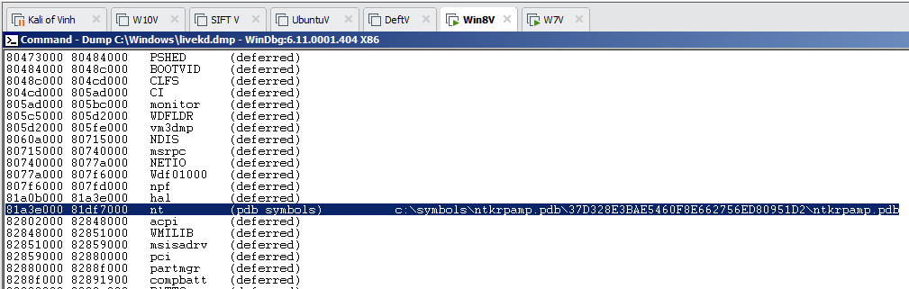

Viewing Memory
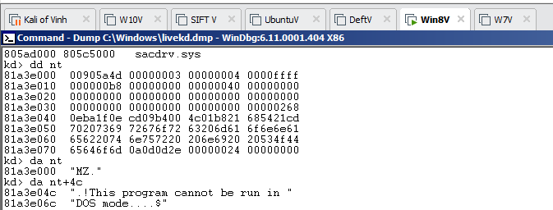

Searching for Functions
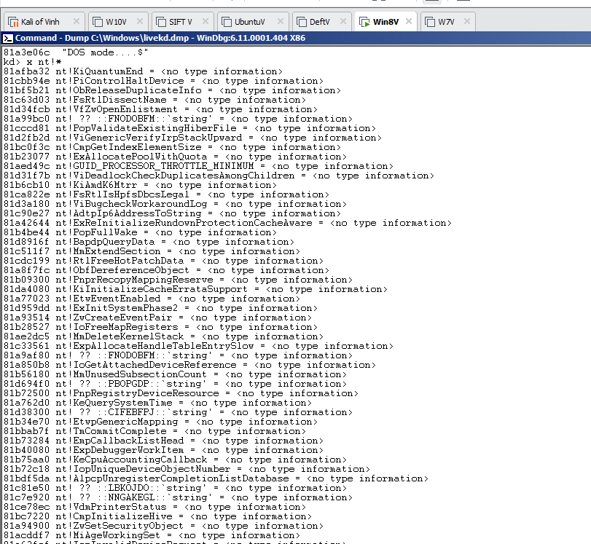
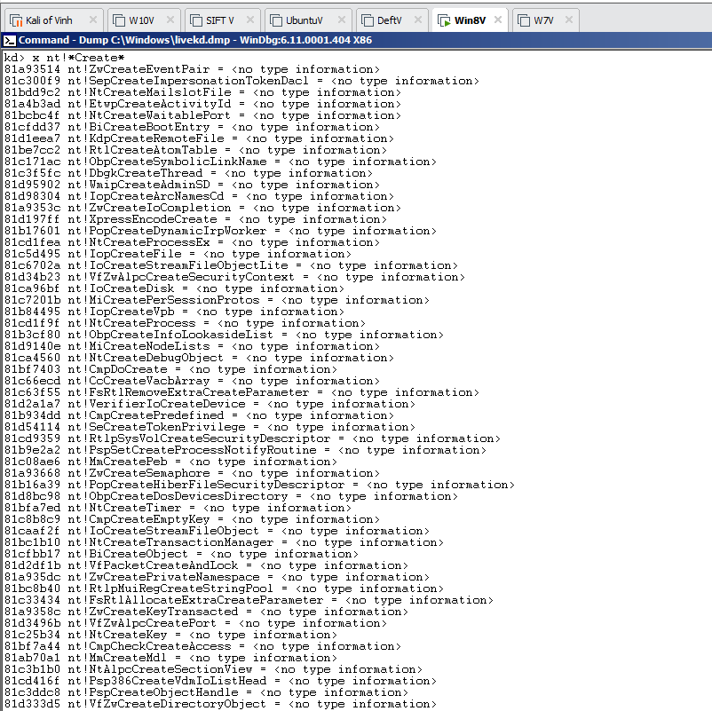
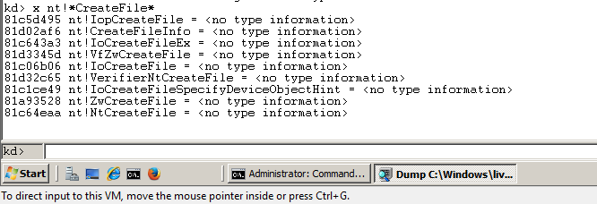

Unassembling a Function
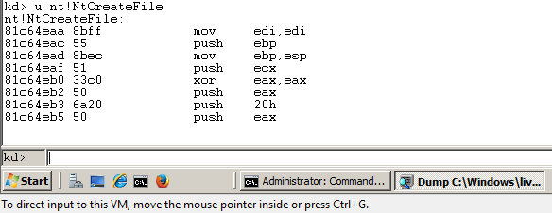

View, Disassembly
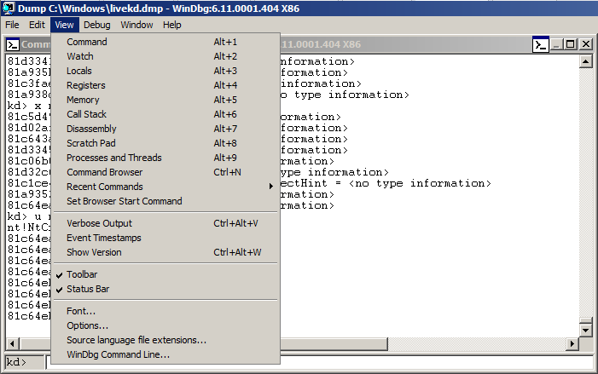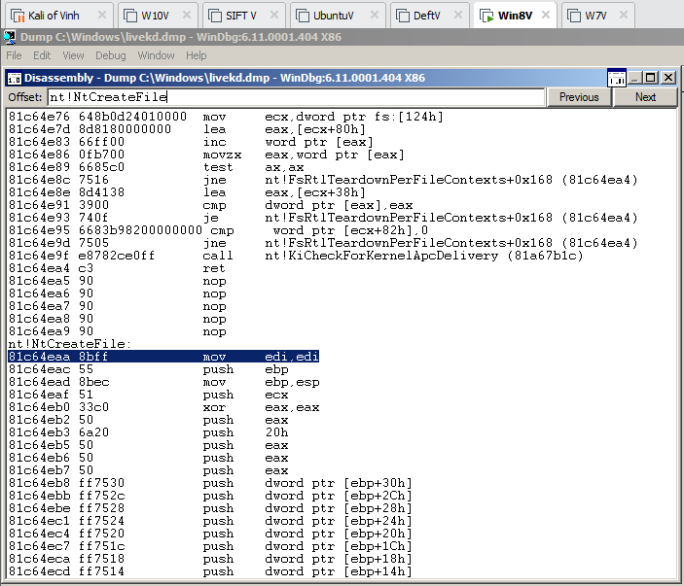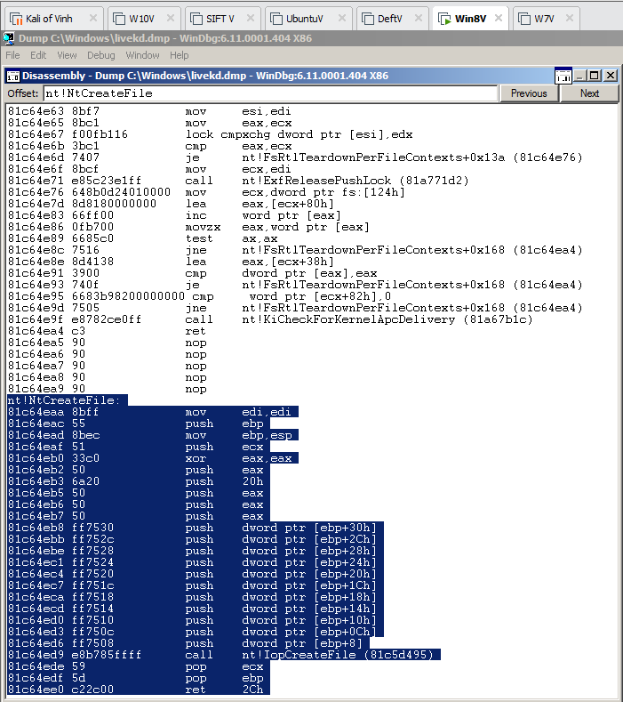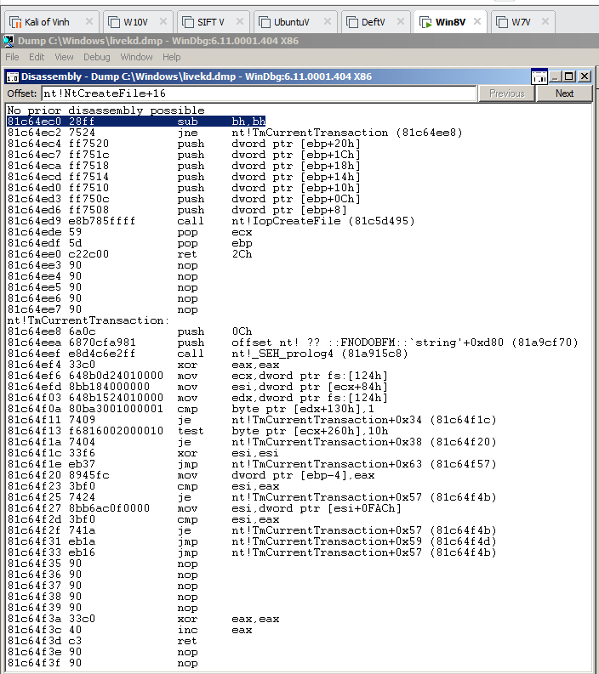

Online Help
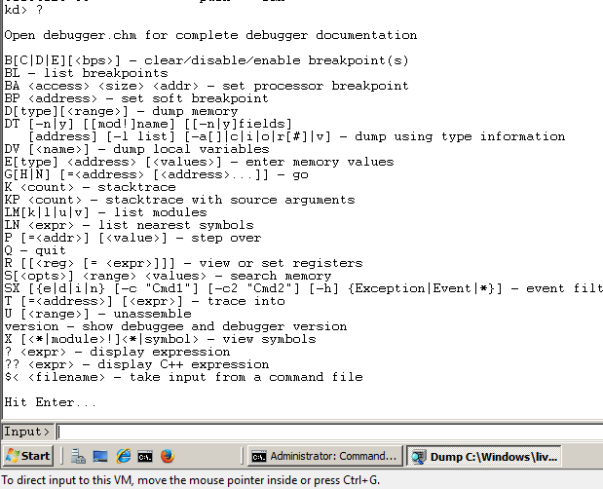
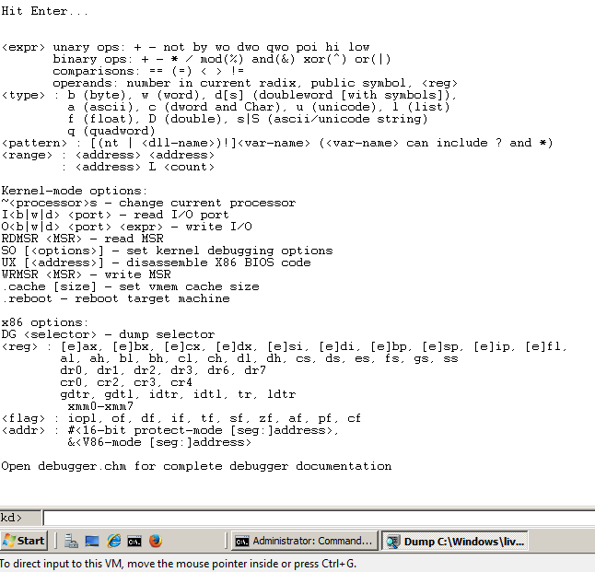

Viewing Type Information for a Structure
